Outbound movement - Alternating flow
The “natural” flow of Openboxes requires advancing through these forms,
of which Edit is fine. 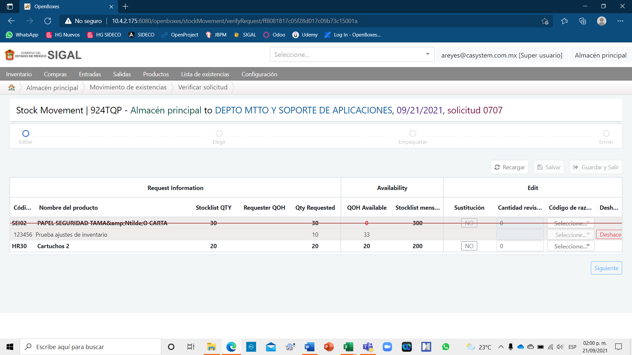
Choosing is also correct 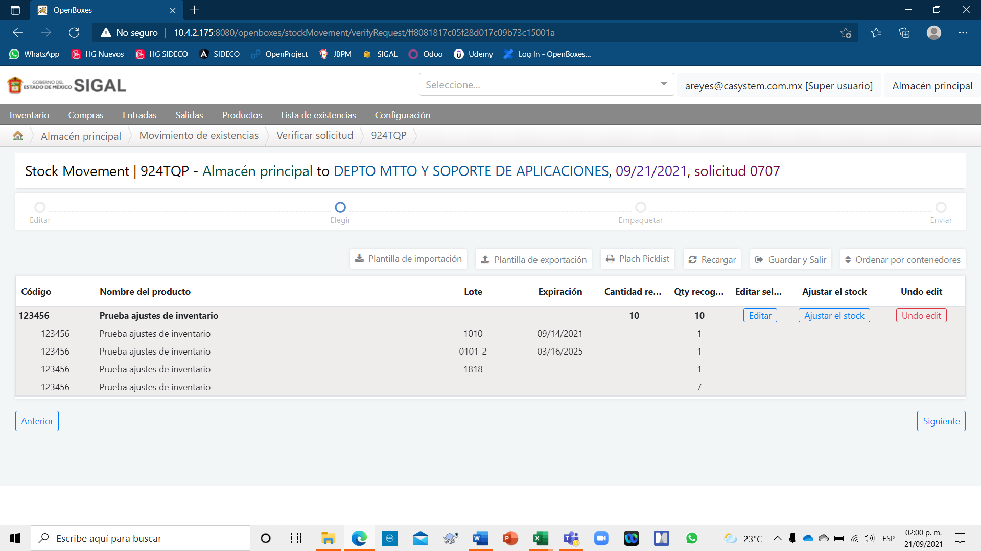

Like Pack 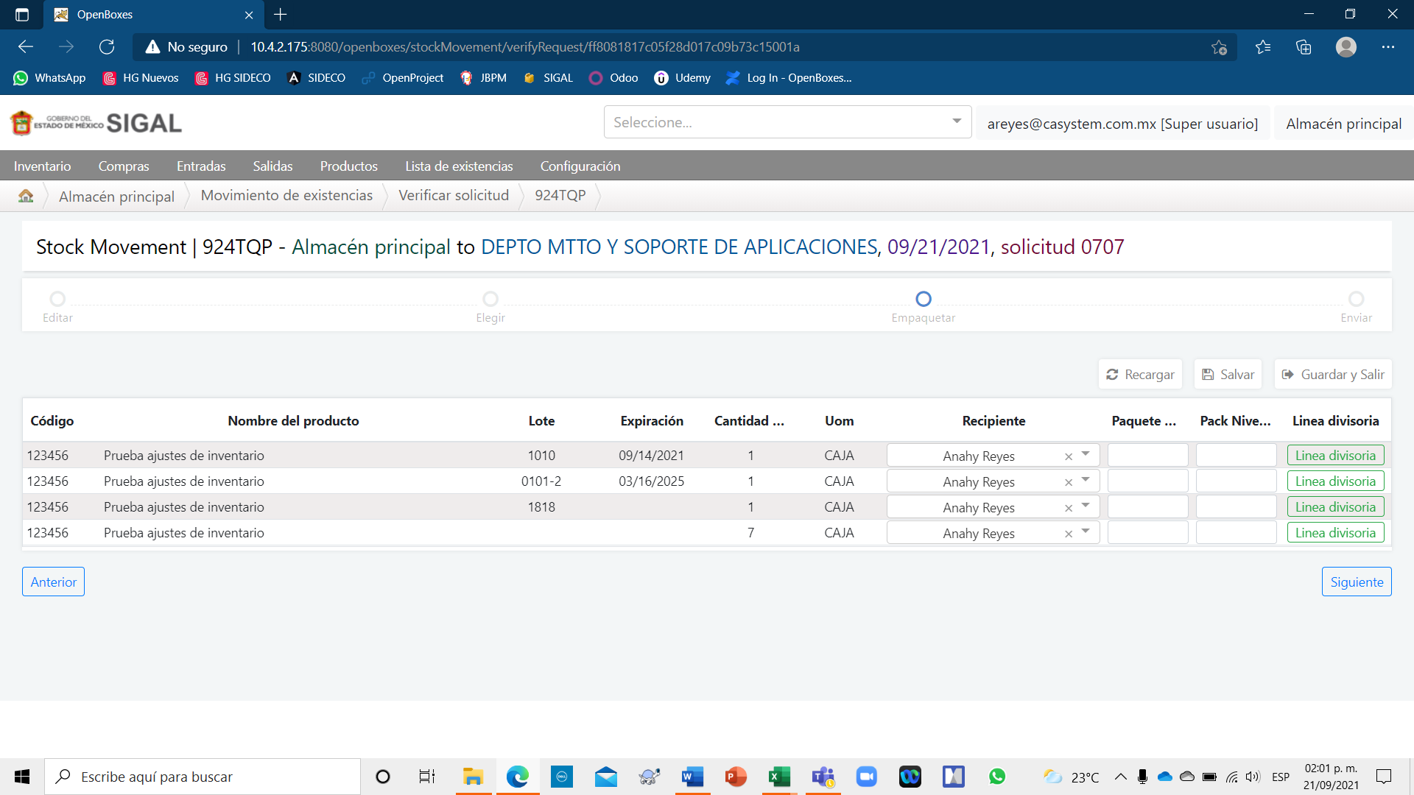
However, this "Submit" follow-up screen is not required for our warehouse process. 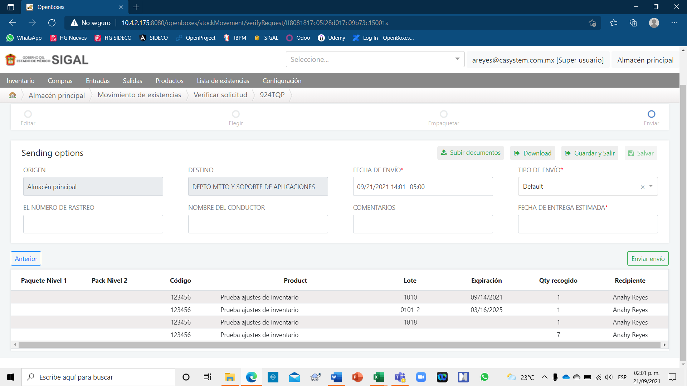

Additionally, it is required to generate the review and approval flow that is managed on this screen; in order to print the support document (Plach Picklist). 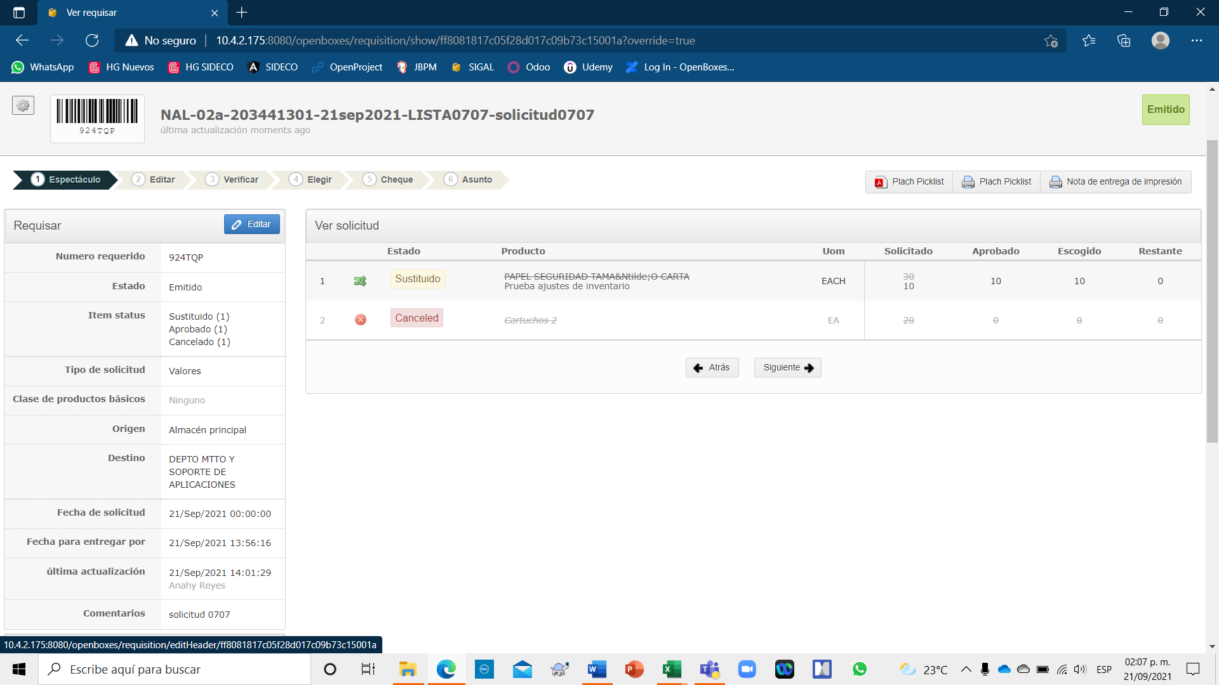
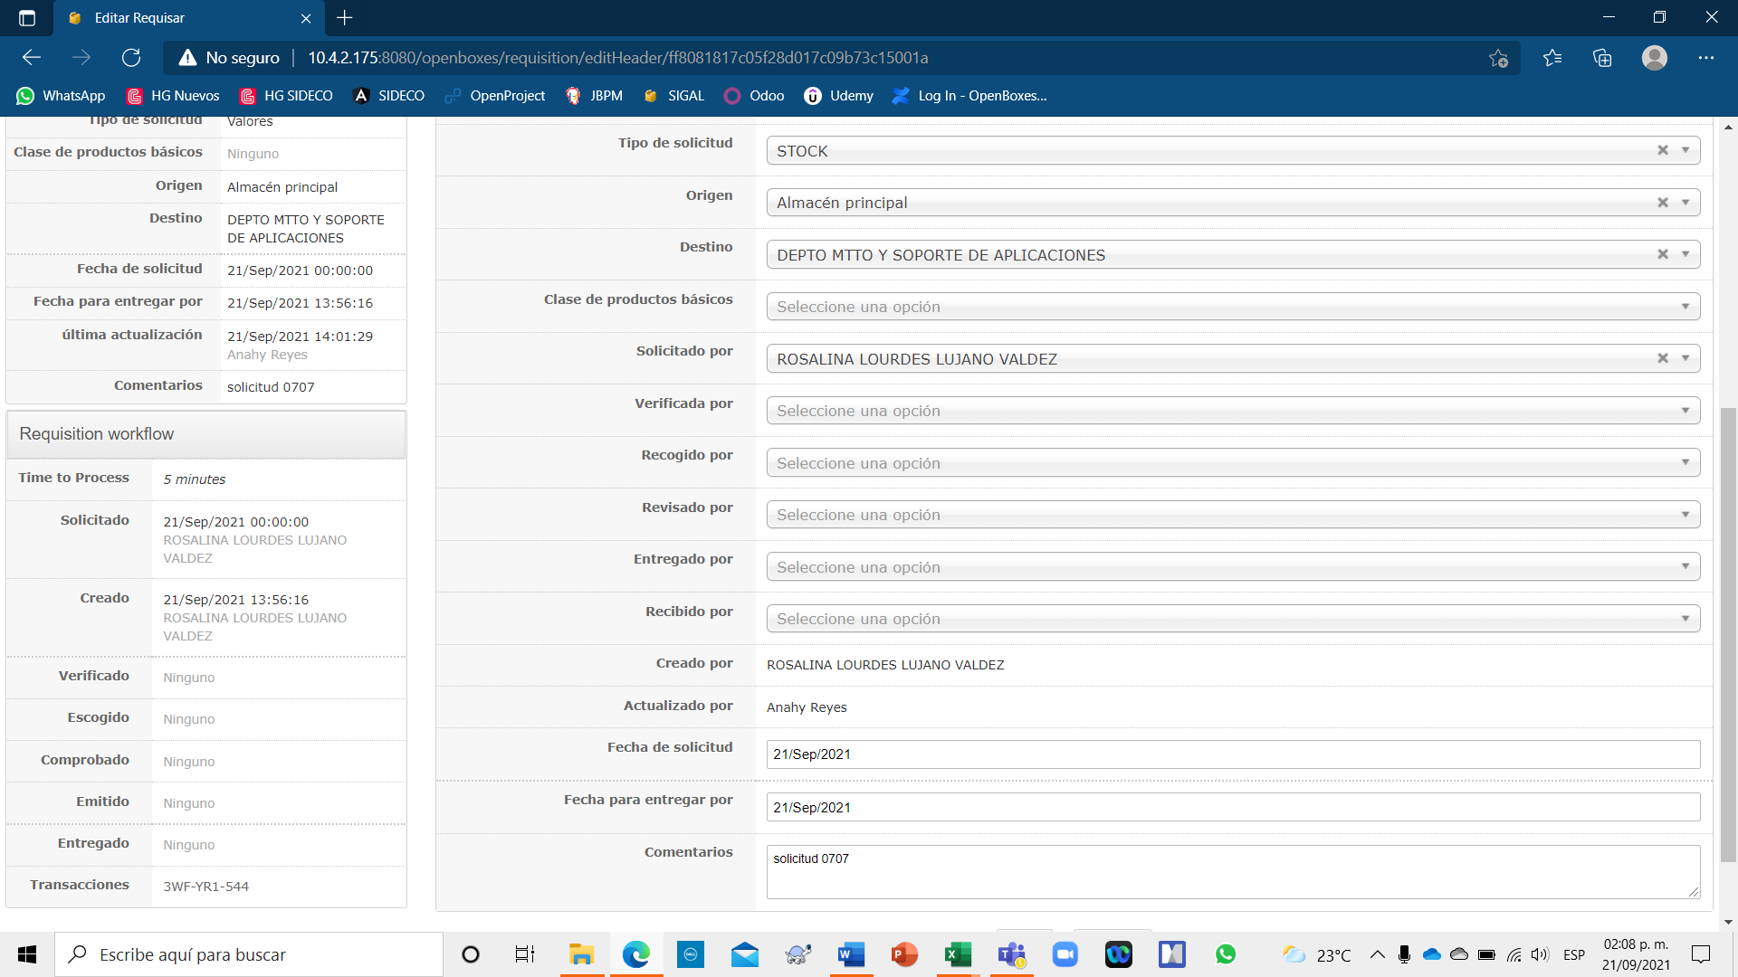
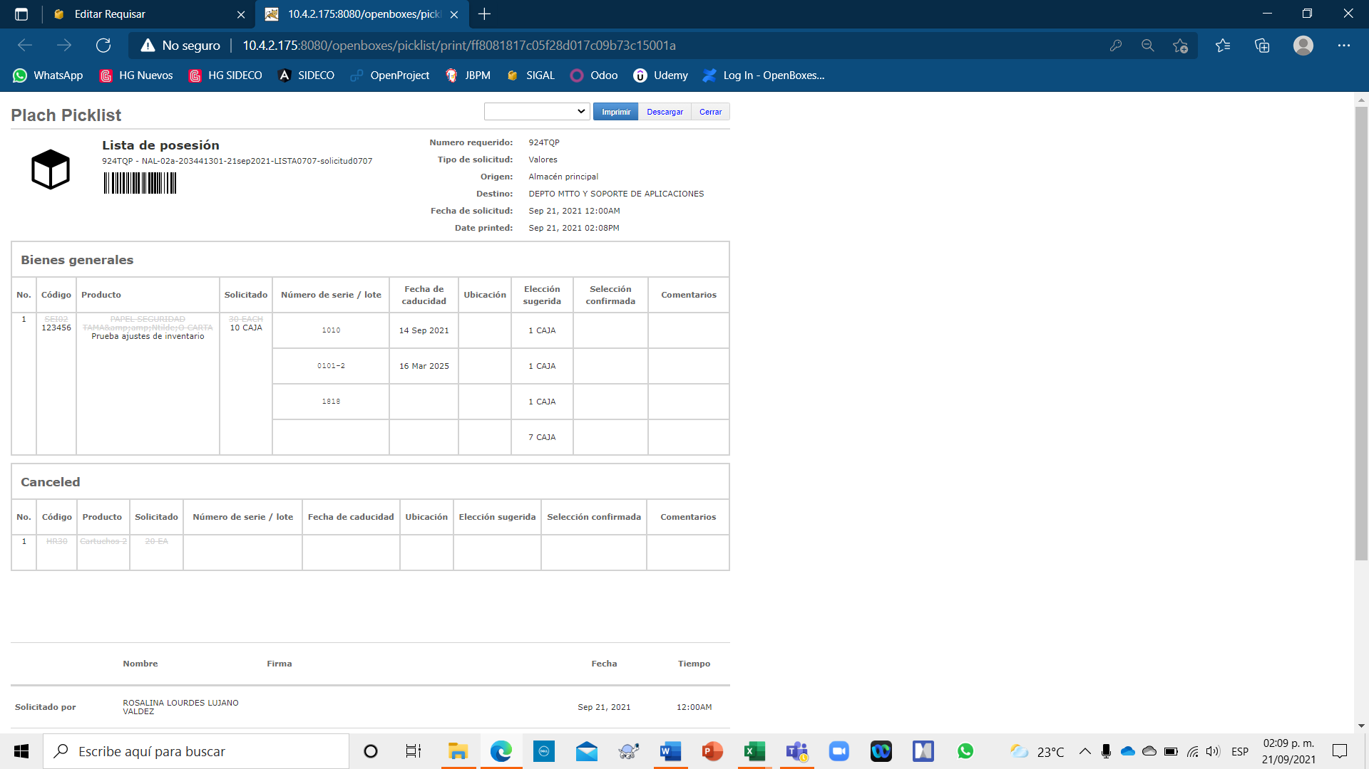

These are the two reasons why we seek to use the "alternate flow"
- Avoid forms that do not apply to the business.
- Obtain the approval forms that are required in the business and that the "Natural Flow" does not allow us to obtain.

