Using a transactional email service (gmail)
The configuration was made to be able to send emails using an email account with a Gmail domain For this, the following adjustments were made. 1. The Openboxes documentation specifies that it can be done with the following configuration,
https://docs.openboxes.com/en/develop/configuration/email/

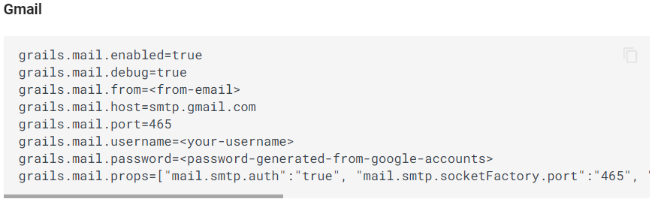
But following this documentation, the problem is presented that the grails.mail.props attribute is not read as an attribute array but as a complete string, which is why the property was changed as follows
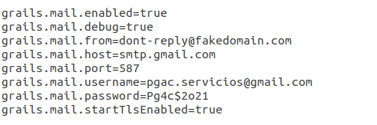
This implied a change in the class “grails-app/services/org/pih/warehouse/core/MailService.groovy”
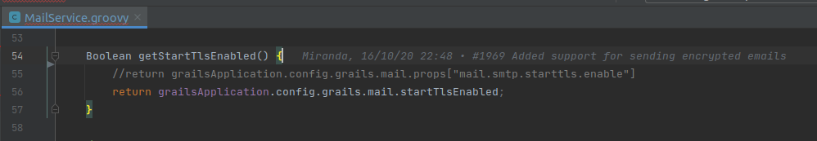
Once this change is made. There is a problem with the secure socket communication protocol, since the java 7 Zulu version (Required according to the Ubuntu configuration manual), has the TLSv1.2 protocol restricted.

This involved making the following change in the code, to explicitly indicate the use of the required version in the class “grails-app/services/org/pih/warehouse/core/MailService.groovy”
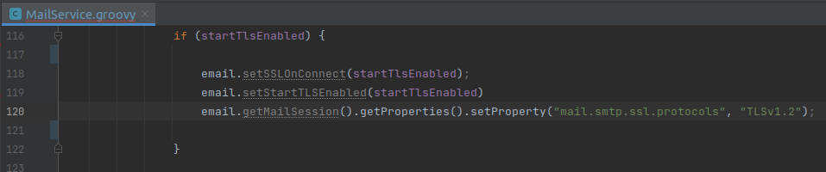
These changes allow the sending of emails through a secure protocol.

Additionally, in the particular case of Gmail, it is required to configure the account to be used for sending emails and thus allow the connection of less secure applications.
